USB 2.0 HUB (7 port)
HU2RB07220H00  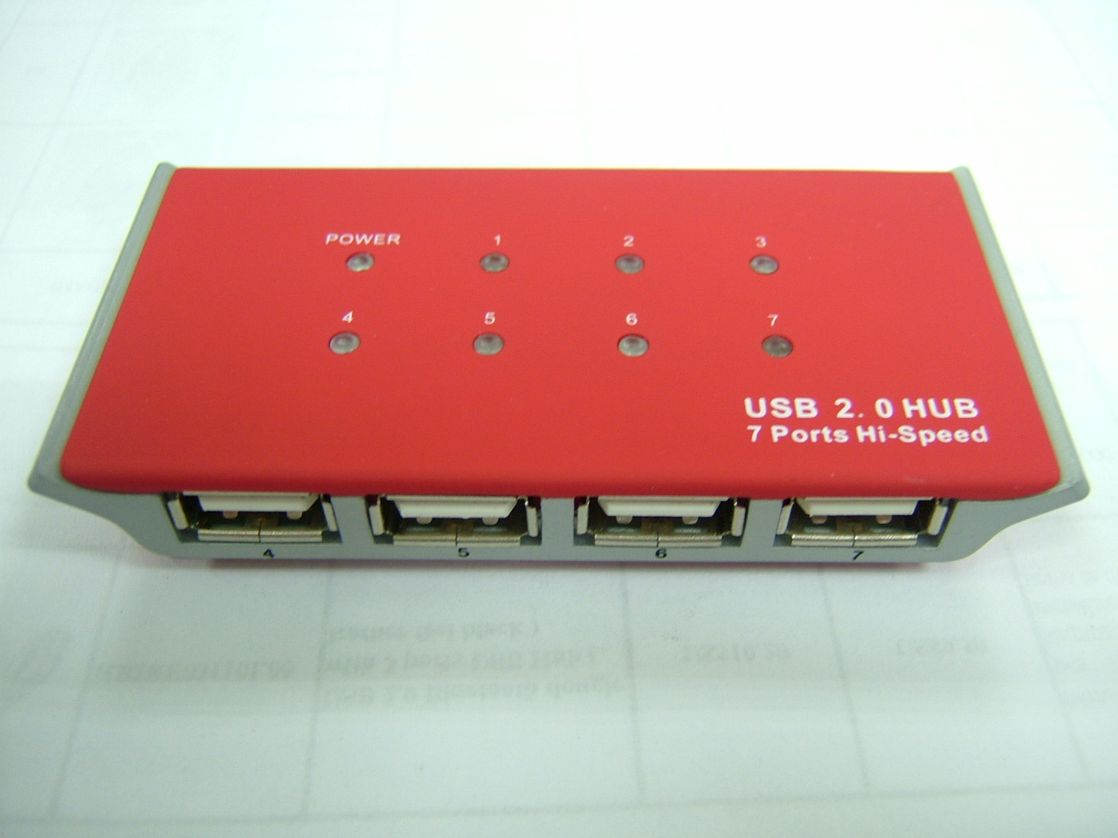 | Carton/ pcs  (L)X(W)X(H)cm  KG(GW)  KG(NW)  CUFT
PRODUCT SIZE(L*W*H)mm
93.1*45.3*15.8
ACCESSORY
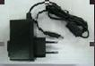
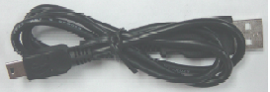
Features :
- Fully compatible with USB 2.0 specification.
Backward compatible with USB1.1.
Support transfer rates up to 480 Mbps.
- Support plug & play.
- Includes power LED and port LED status for each port.
- Self-powered by Universal Serial Bus.
- OS support :
Windows 98/98SE/ME/2000/XP,
MAC OS 9.2 & 10.1.2.3 or later and Linux 2.4.0 or later.
- USB2.0 Hub :
USB2.0 ver.supports high-speed, full-speed and low speed transfer rate
(480Mbps,12Mbps and 1.5Mbps). Also it is compatible USB1.1 port. With
its bandwidth of 480Mbps(exceeding that of IEEE1394 firewires with
400Mbps), the USB2.0 Hub will allow you to connect devices that
consume a great deal of banwidth such as external storage devices.
scanners, printers.DVD drivers,CD-RW Drivers,MO(Magneto-Ootucak)
drivers,and digital cameras/ camcorders to your computer.

